Article Title- Prediction of Mechanical Properties of concrete by Novel Method of Mixing using Artificial Neural Network and Support Vector Regression

Journal name- European Journal of Environmental and Civil Engineering

Author Names:

Corresponding Author:

Mrs Reshma Malipeddi ,M.E

Research Scholar

Department Of Civil Engineering,

Andhra University College Of Engineering,

Waltair Junction

Visakhapatnam-530003,INDIA

E-mail id : reshmamalipeddi@andhrauniversity.edu.in

ORCID id- 0000-0002-6454-0095

Dr.S. Adiseshu ,PhD

Professor

Department Of Civil Engineering,

Andhra University College Of Engineering,

Waltair Junction

Visakhapatnam-530003,INDIA.

Dr.K.Padma, PhD

Associate Professor

Department of Electrical Engineering

Andhra University College of Engineering

Waltair Junction

Visakhapatnam-530003, INDIA

**Supplementary file**

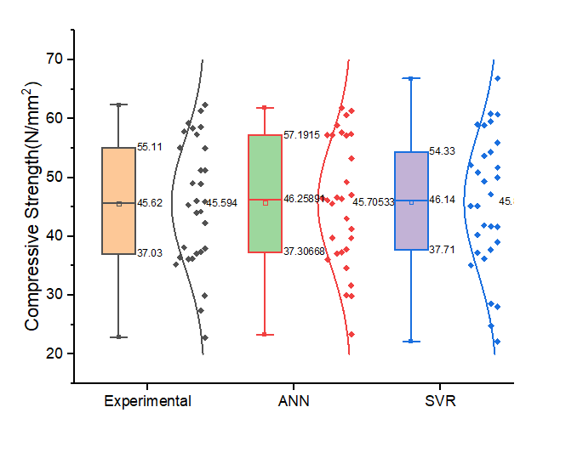

**Fig.S1** Box plot (Normal )for compressive strength results of concrete using novel mixing procedure

**Table S1** Analysis of parameters of box plot pertaining to compressive strength results

|  |  |  |  |
| --- | --- | --- | --- |
| **S.No** | **Method** | **Parameter** | **Range / Value** |
| 1. | Experiment | Minimum | 22.81 |
| Maximum | 62.34 |
| Range | 39.53 |
| Interquartile range | 18.08 |
| Lower quartile range (first) | 22.81-37.03 |
| Mean | 45.594 |
| Median | 45.62 |
| Upper quartile range (third) | 45.62-55.11 |
|  |  |
| 2 | ANN | Minimum | 23.349 |
| Maximum | 61.798 |
| Range | 38.449 |
| Interquartile range | 19.89 |
| Lower quartile range (first) | 13.95 |
| Mean | 45.70 |
| Median | 46.25 |
| Upper quartile range (third) | 46.25-57.19 |
| 3 | SVR | Minimum | 22.14 |
| Maximum | 60.84 |
| Range | 38.7 |
| Interquartile range | 16.62 |
| Lower quartile range (first) | 15.57 |
| Mean | 45 |
| Median | 46.14 |
| Upper quartile range (third) | 46.14-54.33 |

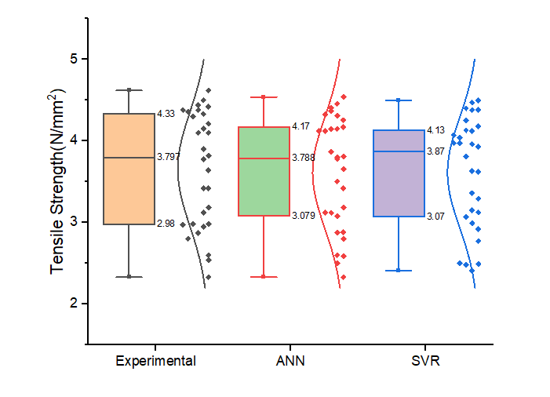

**Fig.S2** Box plot (Normal )for tensile strength results of concrete using novel mixing procedure

**Table S2** Analysis of parameters of box plot pertaining to tensile strength results

|  |  |  |  |
| --- | --- | --- | --- |
| **S.No** | **Method** | **Parameter** | **Range / Value** |
| 1. | Experiment | Minimum | 2.33 |
| Maximum | 4.62 |
| Range | 2.29 |
| Interquartile range | 1.35 |
| Lower quartile range (first) | 0.817 |
| Median | 3.797 |
| Upper quartile range (third) | 0.533 |
|  |  |
| 2 | ANN | Minimum | 2.33 |
| Maximum | 4.539 |
| Range | 2.209 |
| Interquartile range | 1.091 |
| Lower quartile range (first) | 0.749 |
| Median | 3.788 |
| Upper quartile range (third) | 0.382 |
| 3 | SVR | Minimum | 2.41 |
| Maximum | 4.47 |
| Range | 2.06 |
| Interquartile range | 1.06 |
| Lower quartile range (first) | 0.66 |
| Median | 3.87 |
| Upper quartile range (third) | 0.26 |

**Table.S3** Detailed analysis of experimental and predicted values of compressive strength of concrete using novel mixing procedure

|  |  |  |  |  |  |  |
| --- | --- | --- | --- | --- | --- | --- |
| **Exp No.** | **Mix ID** | **Experiment value** | **Predicted ANN** | **Predicted SVR** | **Relative Error (%)ANN** | **Relative Error (%) SVR** |
| 1 | CM | 22.81 | 23.34917996 | 22.14 | 2.3637876 | 2.9373082 |
| 2 | GBS2.5FA0 | 45.92 | 47.02834799 | 51.65 | 2.4136498 | 12.478223 |
| 3 | GBS2.5FA5 | 42.29 | 39.7149072 | 41.62 | 6.0891293 | 1.5842989 |
| 4 | GBS2.5FA10 | 37.92 | 37.7809117 | 39.06 | 0.366794 | 3.0063291 |
| 5 | GBS2.5FA15 | 37.33 | 41.24106788 | 37.71 | 10.47701 | 1.017948 |
| 6 | GBS2.5FA20 | 37.03 | 37.30668419 | 36.16 | 0.7471893 | 2.3494464 |
| 7 | GBS2.5FA25 | 36.22 | 29.87234119 | 41.71 | 17.525287 | 15.157372 |
| 8 | GBS2.5FA30 | 36.15 | 37.05261372 | 24.8 | 2.4968568 | 31.396957 |
| 9 | GBS2.5FA35 | 29.92 | 31.65115988 | 28.09 | 5.7859622 | 6.1163102 |
| 10 | GBS2.5FA40 | 27.4 | 29.97952649 | 28.56 | 9.4143303 | 4.2335766 |
| 11 | CM | 44.22 | 43.02439687 | 49.95 | 2.703761 | 12.957938 |
| 12 | GBS2.5FA0 | 55 | 53.21755624 | 54.33 | 3.2408068 | 1.2181818 |
| 13 | GBS2.5FA5 | 48.9 | 49.26616766 | 53.73 | 0.7488091 | 9.8773006 |
| 14 | GBS2.5FA10 | 46 | 46.39781734 | 47.14 | 0.8648203 | 2.4782609 |
| 15 | GBS2.5FA15 | 49 | 46.63291639 | 49.38 | 4.8307829 | 0.7755102 |
| 16 | GBS2.5FA20 | 45.32 | 46.56463356 | 45.14 | 2.746323 | 0.3971756 |
| 17 | GBS2.5FA25 | 51.23 | 56.33 | 50.85 | 9.9551044 | 0.7417529 |
| 18 | GBS2.5FA30 | 38.1 | 39.71321697 | 37.23 | 4.2341653 | 2.2834646 |
| 19 | GBS2.5FA35 | 36.4 | 34.65063454 | 41.89 | 4.8059491 | 15.082418 |
| 20 | GBS2.5FA40 | 35.2 | 36.0319465 | 35.1 | 2.3634844 | 0.2840909 |
| 21 | CM | 51.23 | 57.37 | 40.28 | 11.985165 | 21.374195 |
| 22 | GBS2.5FA0 | 62.34 | 61.32265757 | 60.72 | 1.6319256 | 2.5986526 |
| 23 | GBS2.5FA5 | 61.33 | 60.61095553 | 66.82 | 1.1724188 | 8.9515735 |
| 24 | GBS2.5FA10 | 58.62 | 57.11445388 | 52.12 | 2.5683148 | 11.088366 |
| 25 | GBS2.5FA15 | 57.34 | 57.63998139 | 55.91 | 0.5231625 | 2.4938961 |
| 26 | GBS2.5FA20 | 58.37 | 58.88951089 | 59.53 | 0.8900306 | 1.9873223 |
| 27 | GBS2.5FA25 | 59.28 | 57.19149545 | 58.88 | 3.5231183 | 0.6747638 |
| 28 | GBS2.5FA30 | 57.84 | 61.79834102 | 59 | 6.8436048 | 2.0055325 |
| 29 | GBS2.5FA35 | 55.11 | 57.20239565 | 60.84 | 3.7967622 | 10.397387 |
| 30 | GBS2.5FA40 | 44 | 46.42404194 | 45.14 | 5.5091862 | 2.5909091 |

**Table.S4** Detailed analysis of experimental and predicted values of tensile strength of concrete using novel mixing procedure

|  |  |  |  |  |  |  |
| --- | --- | --- | --- | --- | --- | --- |
| **Exp No.** | **Mix ID** | **Experiment value** | **Predicted ANN** | **Predicted SVR** | **Relative Error (%)ANN** | **Relative Error (%) SVR** |
| 1 | CM | 3.184 | 3.184 | 3.124 | 0 | 1.8844221 |
| 2 | GBS2.5FA0 | 2.98 | 3.079 | 3.15 | 3.3221477 | 5.704698 |
| 3 | GBS2.5FA5 | 2.95 | 2.88 | 2.92 | 2.3728814 | 1.0169492 |
| 4 | GBS2.5FA10 | 2.87 | 2.877 | 3.07 | 0.2439024 | 6.9686411 |
| 5 | GBS2.5FA15 | 2.98 | 3.12 | 2.49 | 4.6979866 | 16.442953 |
| 6 | GBS2.5FA20 | 2.8 | 2.799 | 2.77 | 0.0357143 | 1.0714286 |
| 7 | GBS2.5FA25 | 2.97 | 2.586 | 2.99 | 12.929293 | 0.6734007 |
| 8 | GBS2.5FA30 | 2.6 | 2.6 | 2.41 | 0 | 7.3076923 |
| 9 | GBS2.5FA35 | 2.54 | 2.5 | 2.48 | 1.5748031 | 2.3622047 |
| 10 | GBS2.5FA40 | 2.33 | 2.33 | 2.5 | 0 | 7.2961373 |
| 11 | CM | 3.42 | 3.42 | 3.62 | 0 | 5.8479532 |
| 12 | GBS2.5FA0 | 4.42 | 4.255 | 3.93 | 3.7330317 | 11.085973 |
| 13 | GBS2.5FA5 | 4.21 | 4.17 | 4.18 | 0.9501188 | 0.7125891 |
| 14 | GBS2.5FA10 | 4.1 | 4.15 | 4.12 | 1.2195122 | 0.4878049 |
| 15 | GBS2.5FA15 | 4.33 | 4.31 | 4.38 | 0.4618938 | 1.1547344 |
| 16 | GBS2.5FA20 | 4.15 | 4.146 | 3.96 | 0.0963855 | 4.5783133 |
| 17 | GBS2.5FA25 | 4.38 | 3.81 | 3.63 | 13.013699 | 17.123288 |
| 18 | GBS2.5FA30 | 3.82 | 3.8 | 3.81 | 0.5235602 | 0.2617801 |
| 19 | GBS2.5FA35 | 3.64 | 3.655 | 3.974 | 0.4120879 | 9.1758242 |
| 20 | GBS2.5FA40 | 3.12 | 3.12 | 3.29 | 0 | 5.4487179 |
| 21 | CM | 3.774 | 3.776 | 3.974 | 0.0529942 | 5.2994171 |
| 22 | GBS2.5FA0 | 4.62 | 4.539 | 4.13 | 1.7532468 | 10.606061 |
| 23 | GBS2.5FA5 | 4.3 | 4.368 | 4.5 | 1.5813953 | 4.6511628 |
| 24 | GBS2.5FA10 | 4.36 | 4.325 | 4.38 | 0.8027523 | 0.4587156 |
| 25 | GBS2.5FA15 | 4.5 | 4.4566 | 4.47 | 0.9644444 | 0.6666667 |
| 26 | GBS2.5FA20 | 4.38 | 4.402 | 4.4 | 0.5022831 | 0.456621 |
| 27 | GBS2.5FA25 | 4.44 | 4.12 | 4.25 | 7.2072072 | 4.2792793 |
| 28 | GBS2.5FA30 | 4.1 | 4.12 | 4.04 | 0.4878049 | 1.4634146 |
| 29 | GBS2.5FA35 | 3.9 | 3.865 | 4.07 | 0.8974359 | 4.3589744 |
| 30 | GBS2.5FA40 | 3.42 | 3.504 | 3.36 | 2.4561404 | 1.754386 |

A B

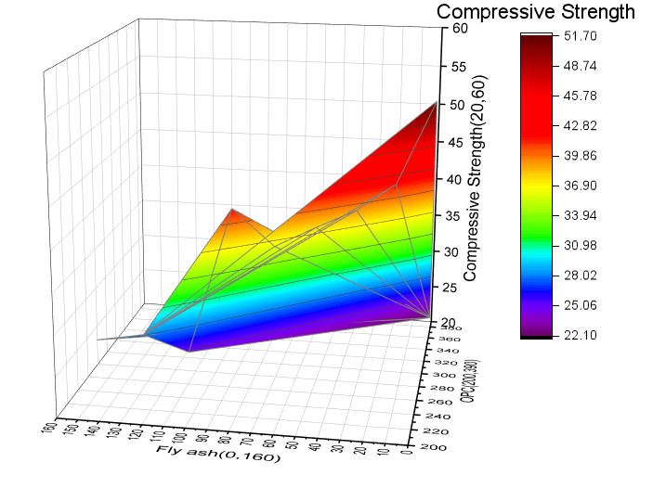 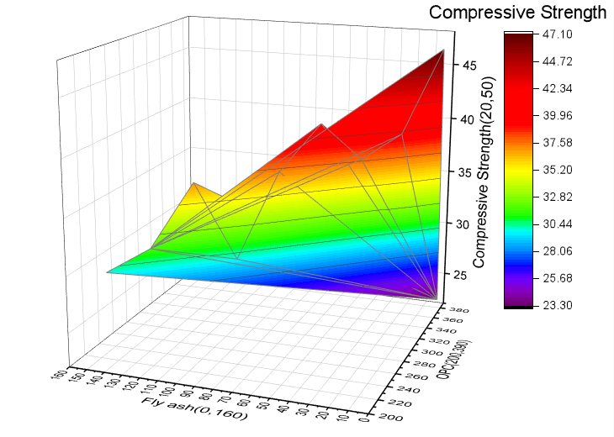

Note : Units of X-axis and Y-axis: (kg/m3) , Z-axis : N/mm2

**Fig.S3** 3D plot for 7 days compressive strength as per Support Vector Regression(A) and Artificial Neural Network (B)

A B

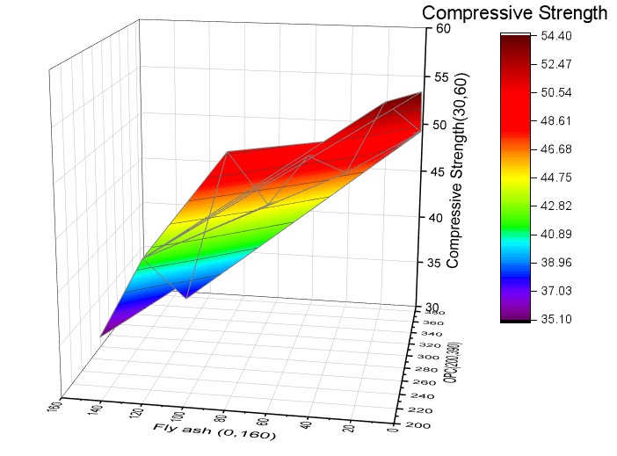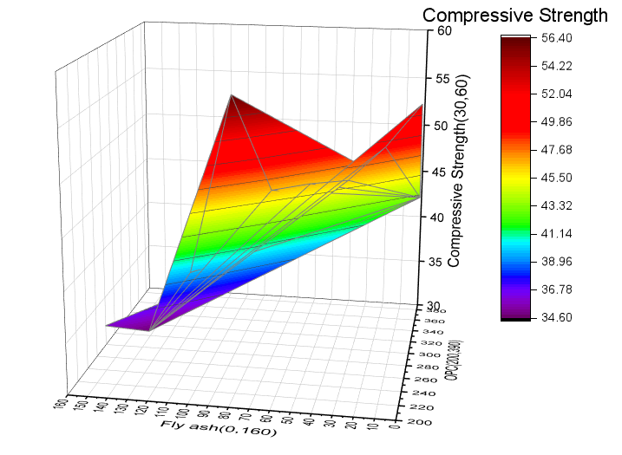

Note : Units of X-axis and Y-axis: (kg/m3) , Z-axis : N/mm2

**Fig.S4** 3D plot for 28 days compressive strength as per Support Vector Regression(A) and Artificial Neural Network (B)

**A B**

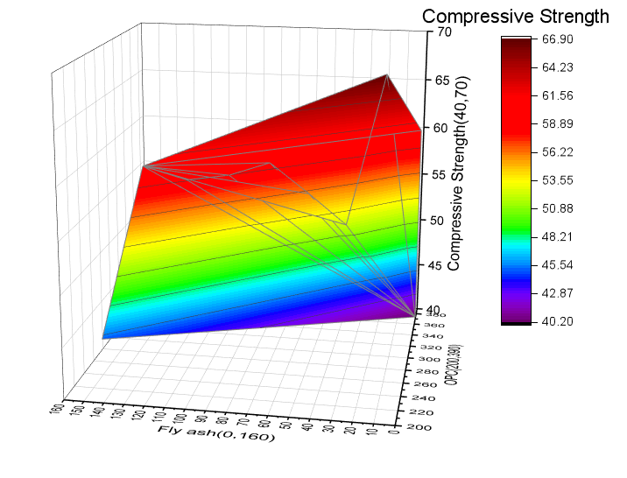 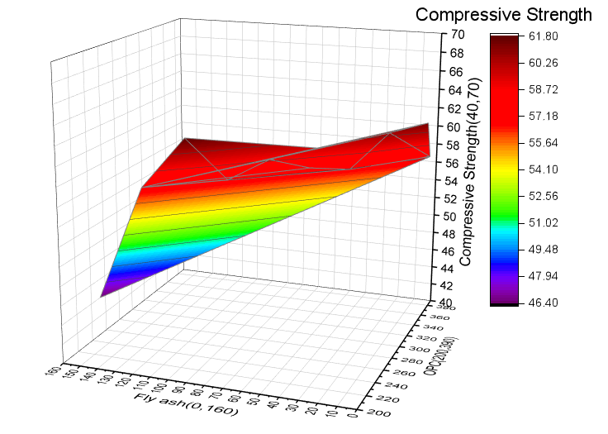

Note : Units of X-axis and Y-axis: (kg/m3) , Z-axis : N/mm2

**Fig.S5** 3D plot for 90 days compressive strength as per Support Vector Regression(A) and Artificial Neural Network (B)

A B

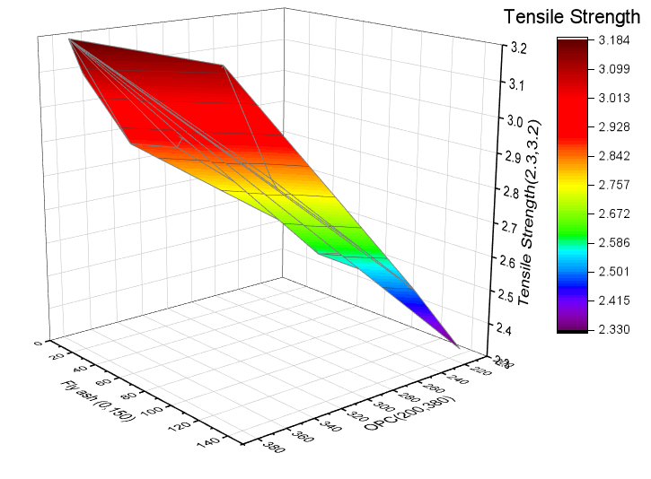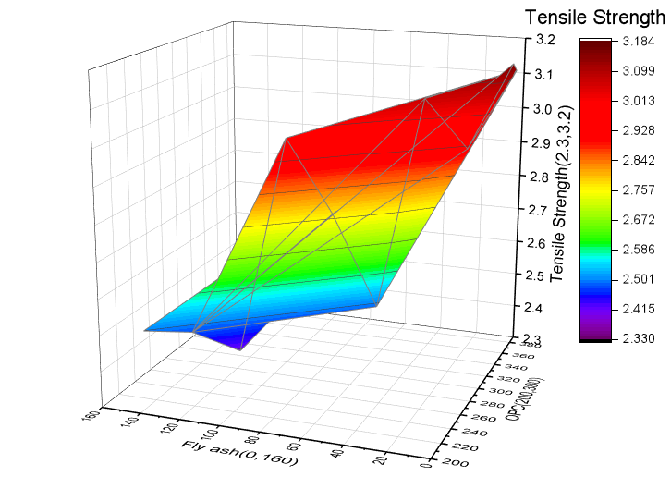

Note : Units of X-axis and Y-axis: (kg/m3) , Z-axis : N/mm2

**Fig.S6** 3D plot for 7 days tensile strength as per Artificial Neural Network (A)and Support Vector Regression (B)

**A B**

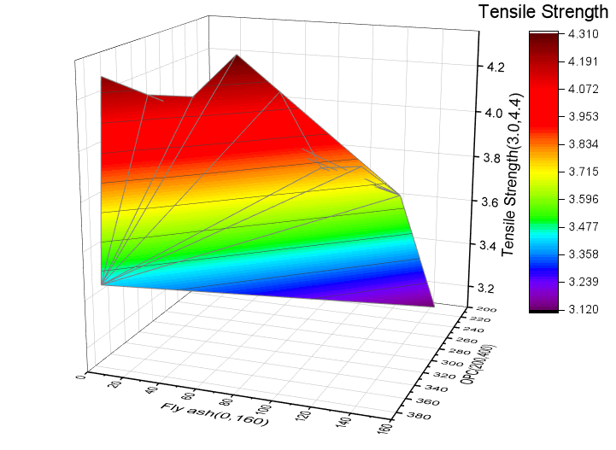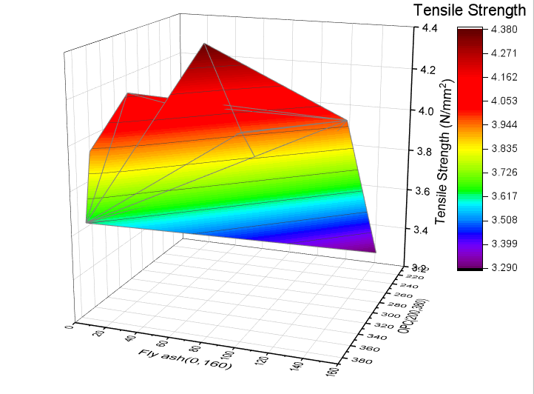

Note : Units of X-axis and Y-axis: (kg/m3) , Z-axis : N/mm2

**Fig.S7** 3D plot for 28 days tensile strength as per Artificial Neural Network(A) and Support Vector Regression(B)

A B

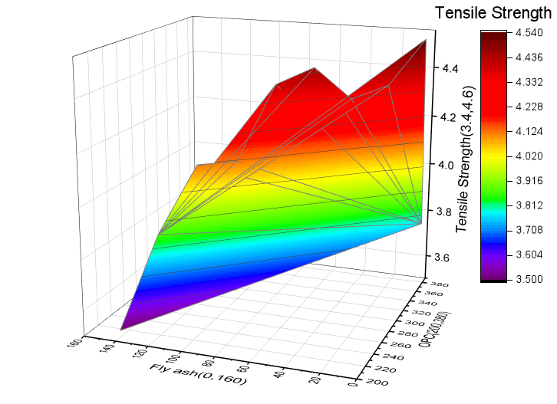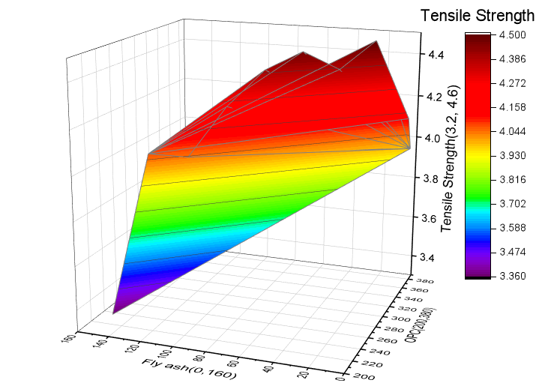

Note : Units of X-axis and Y-axis: (kg/m3) , Z-axis : N/mm2

**Fig.S8** 3D plot for 90 days tensile strength as per Artificial Neural Network(A) and Support Vector Regression(B)